HEI Funding for Promotion of Languages
Interim Report - 2023-2024
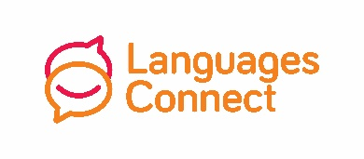
Name of HEI

Name of funding coordinator

Coordinator’s email

Coordinator’s mobile number
Name of #ThinkLanguages coordinator
Email address of #ThinkLanguages coordinator
Please provide dates for all events, award ceremonies, competitions, language days or weeks, etc. for the academic year 2023-2024
Name of event, etc. | Dates

Please submit to Nellie Tattersall nellie.tattersall@ppli.ie by Friday 27th October 2023.

