HEI Funding for Promotion of Languages
Annual Report - 2023-2024
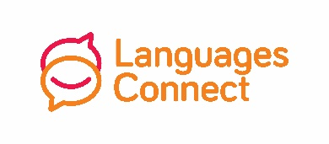
Please fill in the project details for each section of your funding, and use as much space as you need.
Name of HEI

Name of Coordinator

Coordinator’s Email

Total Amount of Funding Received
Total Amount of Funding Spent
Project 1 – Expenditure – please itemize all spending

Project 1 – Outline – please give an overview, including facts, figures, audience, location, etc.

Project 1 – Outcome – please outline the impact on the target audience

Project 1 – Links – please provide links to videos, websites, etc.

Project 1 – Promotion – please provide links to social media posts, local papers, etc.

Project 2 – Expenditure – please itemize all spending

Project 2 – Outline – please give an overview, including facts, figures, audience, location, etc.

Project 2 – Outcome – please outline the impact on the target audience

Project 2 – Links – please provide links to videos, websites, etc.

Project 2 – Promotion – please provide links to social media posts, local papers, etc.

Project 3 – Expenditure – please itemize all spending

Project 3 – Outline – please give an overview, including facts, figures, audience, location, etc.

Project 3 – Outcome – please outline the impact on the target audience

Project 3 – Links – please provide links to videos, websites, etc.

Project 3 – Promotion – please provide links to social media posts, local papers, etc.

Project 4 – Expenditure – please itemize all spending

Project 4 – Outline – please give an overview, including facts, figures, audience, location, etc.

Project 4 – Outcome – please outline the impact on the target audience

Project 4 – Links – please provide links to videos, websites, etc.

Project 4 – Promotion – please provide links to social media posts, local papers, etc.

Project 5 – Expenditure – please itemize all spending

Project 5 – Outline – please give an overview, including facts, figures, audience, location, etc.

Project 5 – Outcome – please outline the impact on the target audience

Project 5 – Links – please provide links to videos, websites, etc.

Project 5 – Promotion – please provide links to social media posts, local papers, etc.

Please submit to Nellie Tattersall nellie.tattersall@ppli.ie along with any relevant photos by Friday 31st May 2024.

