HEI Funding for Promotion of Languages
Interim Report - 2022-2023
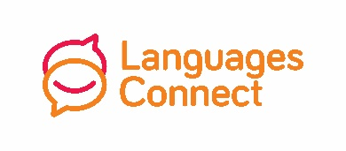
Name of HEI

Name of coordinator

Coordinator’s email

Coordinator’s mobile number
HEIs should enlist language champions from their student population that will represent them and speak on their behalf at #ThinkLanguages, the TY languages event on 17 November 2022. PPLI will provide details of the language champion coordinator to participating schools.
Name of language champion coordinator
Email address of language champion coordinator
HEIs should use social media as well as their own websites to promote and disseminate any projects. These should be official HEI social media accounts. All posts should tag Languages Connect @langsconnect_ie
Please list the social media accounts
Please provide dates for any events, award ceremonies, competitions, language days or weeks, etc.
Name of event, etc. | Dates

Please submit to Nellie Tattersall nellie.tattersall@ppli.ie by Friday 28th October 2022.

